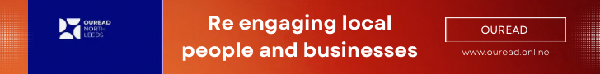

OUREAD Local

North Leeds Monthly Magazine

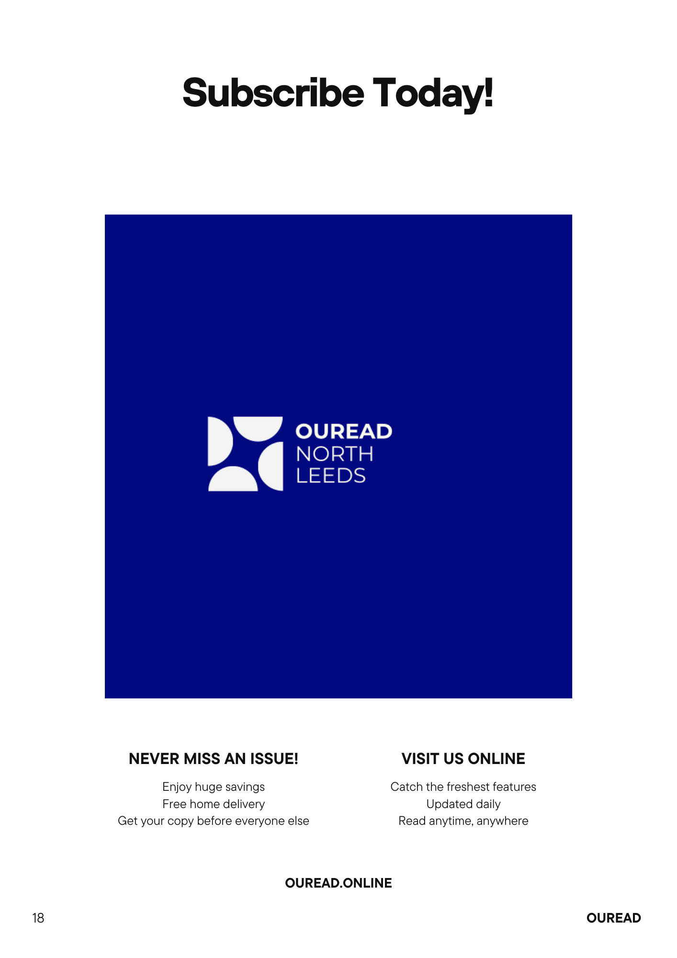

sales@ouread.online]

[07918004220)

Date: 21st April 2025

Dear [Business Owner’s Name],

Re: Advertise Your Business in OUREAD Local – North Leeds Monthly Edition

We’re delighted to offer you the opportunity to promote your business in OUREAD Local, North Leeds’ trusted and widely-read monthly magazine, delivered directly into the hands of thousands of local households and businesses.

Advertising with OUREAD Local offers a number of key benefits:

1. Direct Reach to Your Local Audience

Our magazine is distributed monthly across North Leeds, ensuring your business is seen by the people who live, work, and spend in your area.

2. Build Local Trust and Recognition

OUREAD Local is a well-respected community magazine. Being featured within our pages enhances your reputation and builds trust with potential customers right on your doorstep.

3. Affordable and Flexible Options

We offer a range of advertising packages to suit all budgets — from quarter-page placements to full-page features — with discounts available for long-term bookings.

4. Professional Design Support

Don’t have an ad ready? No problem. Our in-house team can help you create a compelling and professional advertisement at no extra cost.

5. Community-Driven Content

By advertising with us, you also support local journalism and help us keep our content free, relevant, and community-focused.

We would love to help your business grow by connecting you with a loyal and engaged local readership. If you’re interested in securing a spot in an upcoming edition, or would like to discuss options, please get in touch.

***We look forward to working with you.***

***Warm regards,***

***[Charles Rudd***

***Advertising Manager***

***OUREAD Local – North Leeds Edition***

***[sales@ouread.online]***

***07918004220]***