OUR ADS REPORT

Advertising locally for local businesses & local people

**Hey reader**

**is a multi-billion pound industry and growing at up to 15% a year.**

**1 in 3 households now pays for domestic help.**

**There is a huge demand for local services.**

**Are you serious about wanting your own online business? Leverage other people’s time to earn your own income.**

**Unrestricted income as you expand your business. The cleaners do the work and you take a percentage.**

**Most people fail by becoming their business. You will learn how to manage the company - not be the company.**

**The truth is, if you know how to market other people’s time properly the potential for you to make money is endless.**

**You will discover how to source 100’s of potential contractors.**

**We will create your online business FOR YOU...**

**You’ll find out how to get sales bookings passively online 24/7...**

**We will show you how to do EVERYTHING**

**Skip 18 months of research, learning and costly mistakes and start earning from month one.**

**You’ll have ongoing support via our dedicated WhatsApp group with Charles to assist you in any questions you may have along the way.**

**Open to hearing more?**

**Click below to learn EXACTLY how to begin!**

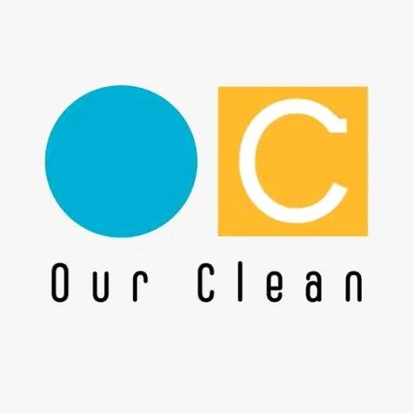Our Group

**Franchise agreement**

# INTRODUCTION

# Our Group is a group of independent businesses in a variety of industries.

# Giving all income based people the chance to earn, develop and manage their own business as a independent concern with the backing and power of a brand.

# Cleaning, a gold and antique buying and selling service, a artificial grass design and installers and a advertising business is just some of the industries that currently we have in operation and opportunities for franchise agreements.

# With the our group brands marketing and advertising large buying power it makes it possible for small individual business to use national marketing mixes and campaigns which get the brand awareness necessary in this day of age.

# 

# HYPOTHESIS

# To Join the group you first need to have a consultation with our agents and let's show you how we can show you our philosophy and way we operate and what ROI we can offer you

# MATERIALS

* 1. We as a brand provide most of the materials required in the different companies we host, some the customer will provide such as cleaning products.

B. We provide marketing merchandise and literature required to PR the businesses.

# **PROCEDURE**

# Contact the Our Group team and arrange a consultation to discuss your business ideas and or management of Branding, awareness, marketing and advertising resulting in a successful business model.

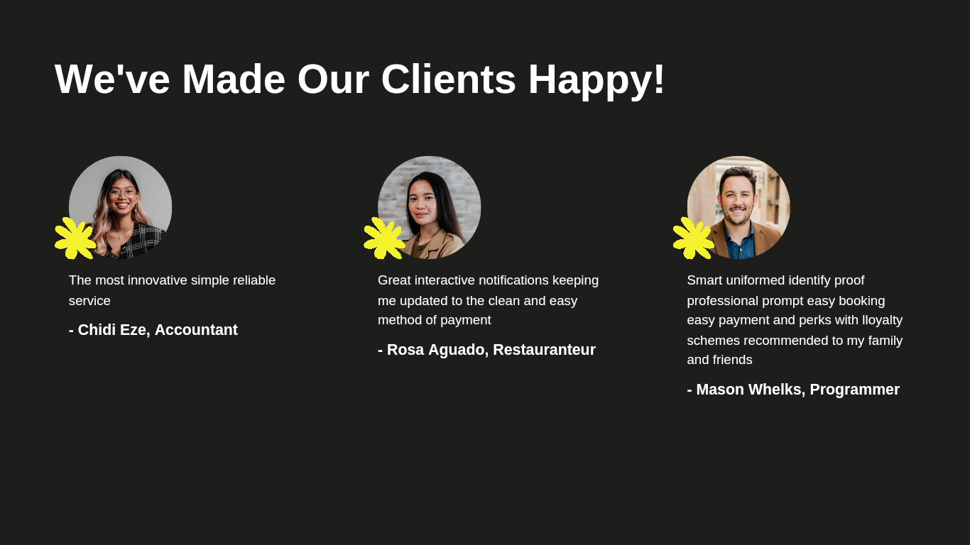



OUR CLEAN UK

OUR GROUP UK

# **Franchise opportunities**

What’s the most important thing that being a franchisee will help you to achieve? Is it:

Autonomy and a sense of independence?

Financial freedom and security for you and your family?

Making a difference in real people’s lives?

Becoming an integral part of an industry you love?

Being part of something bigger than yourself?

# 

# **Franchise options with our clean**

### 

With an industry that every home workplace, care home school and university require in fact and there's not many industries that doesn't require cleaning.

You have wanted to start your own cleaning business for not being able to find the funds being able to do the marketing and advertising purchase equipment recruitment so on then maybe a franchise with our clean is for you.

The latest technology application based cleaning service it's just what you as the customer or user client require.

Having the power of a brand with buying power marketing campaigns and exciting merchandise already complete for you make things a lot more simple.

We offer flexible hours, flexible locations and huge opportunities of growth within our clean and our group brand.

Why franchising is a great opportunity is because it gives people the opportunity to start and manage their own independent business with the power of a national brand this means you already have a custom base, you have national marketing and advertising campaigns and recruitment in HR becomes easier with the brand behind you.

[](https://commons.wikimedia.org/wiki/File:App_Store_(iOS).svg)

OUr Clean app

The modern way to book a cleaner or two to recruit cleaning staff.

Simply download the app from the play store or app store enter your postcode and fill the criteria in.

Enter the details and specifics for your clean. This will generated an instant quote, our nearest geographical cleaner will accept the job and arrange with you the customer and them the contractor the details and timetable for the clean. We aim for each cleaner to fill their diary with 2 cleans a day and having the same custom base week in week out.

The simple modern technology of today enables us to organise, keep updated remotely know how and what's happening with the domestic chores that our personal cleaning agent is doing.

Sharing a interactive message service, a simple safe method for booking, invoice and payment and reviews, this latest technology is the first of its quality from the Our Group cleaning division in Leeds and growing across the UK.

With regards to the contractor side of the app, this acts as a workmate, with bookongs, timesheet, payslip, a inventory form for restocking cleaning products for the next clean which is automatically ordered via Amazon and delivered to the address the next day.

Information between customer and contractor with vacant homes to clean will instruct contractors to a key box to gain entry

The contractor app has a GPS and GSM facility on the app, this is to ensure security is paramount and to prevent contractors intercepting customers behind our back, showing the contractor is in breach of contract if they are shown at a customers address outside of contract.

[](https://www.google.com/search?safe=active&tbm=isch&q=cleaning+&tbs=sur:fmc)

[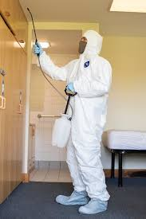](https://www.google.com/search?safe=active&tbm=isch&q=cleaning+&tbs=sur:fmc)

How to find investment for a franchise with Our Group UK?

Before you start searching for franchise finance, you first need to understand the total investment required, including all costs associated with the set-up of the business and the amount required for working capital, fees, VAT, etc.

In order to identify this, you need to prepare a detailed business plan with a full set of financial projections. You can then be clear how much of the total you can contribute and how much you will need to borrow.

[](https://www.thebluediamondgallery.com/handwriting/f/forecasting.html)

**Projections and forecast**

The profit and loss projections will show the trading activity for the business, sales, costs and how much profit you expect to make. The cash flow forecast will set out the incoming investment from you and any finance, the set-up costs going out, the money coming in and out through the trading activity and VAT.

In simple terms, it’s a forecast of what your bank account will look like at the end of each month.

As it’s part of an application for finance, the business plan needs to include all the information required by the person who’s evaluating your proposal on behalf of the lender.

It should start with an executive summary, which will give a concise overview of the business opportunity and funding requirement. It needs to identify who the owners of the business will be and provide their personal information, including CVs.

You also need to include details of their personal assets (house, investments and savings) and liabilities (mortgages, loans, credit cards, etc).

The lender will want to see that your overall family income is sufficient to cover your overall family/household expenditure, taking into account the money you will earn from your new franchise.

The business plan should include information about the franchisor, the business model, how the franchisor will train and support you and how the products or services will be marketed. It should also set out your business objectives.

**Credit score**

Keeping your personal credit score in good shape is important. If you’ve not checked it recently, it makes sense to do this and deal promptly with any adverse issues.

It’s also likely that you will be required to provide your bank statements to evidence the fact you operate your bank accounts well and within any agreed borrowing limits.

If you follow these guidelines, you are likely to be able to successfully raise the capital you need **Charles Rudd CEO**

Fast track your revenue using local and national marketing techniques...

# We will help you to grow a strong cleaning portfolio using Best Practices...

# Our fully optimized website attracts, educates and converts customers

# 

# Creation of your own dedicated webpage for local, personalized content.

# 

# Full access to Direct Mailers, Brochures and Email Templates.

# 

# Your own dedicated Facebook Page for local news and property availability.

# 

**and much more…**

For further information contact Our Clean UK Leeds

[OUrclean@Reborn.com](mailto:OUrclean@contractor.net)

Regards

## CEO James Rudd

JRudd

The home domestic cleaning industry is a multi-billion pound industry and growing up to **15%** a year.

**1** in **3** households now pays for domestic help.

There is a huge demand for local services.

Are you serious about wanting your own online business? Leverage other people’s time to earn your own income.

Unrestricted income as you expand your business. The cleaners do the work and you take a percentage.

Most people fail by becoming their business. You will learn how to manage the company - not be the company.

The truth is, if you know how to market other people’s time properly the potential for you to make money is endless.

You will discover how to source 100’s of potential contractors.

We will create your online business FOR YOU...

You’ll find out how to get sales bookings passively online 24/7...

**We will show you how to do EVERYTHING**

Skip **18 months** of research, learning and costly mistakes and start earning from month one.

You’ll have **ongoing support via our dedicated WhatsApp group with Charles** to assist you in any questions you may have along the way.

**Open to hearing more?**

Click below to learn EXACTLY how to begin!

# Local Advertising

At every stage of your business journey, you will be supported by a team of experts who have years of combined experience in all of the key areas required for business success, such as fitness, sales, marketing, operations and technology.

**Our Group**

**Franchise agreement**

**INTRODUCTION**

Our Group is a group of independent businesses in a variety of industries.

Giving all income based people the chance to earn, develop and manage their own business as an independent concern with the backing and power of a brand.

Cleaning, a gold and antique buying and selling service, an artificial grass design and installers and an advertising business are just some of the industries that currently we have in operation and opportunities for franchise agreements.

With our group brands marketing and advertising large buying power it makes it possible for small individual businesses to use national marketing mixes and campaigns which get the brand awareness necessary in this day of age.

**HYPOTHESIS**

To Join the group you first need to have a consultation with our agents and let's show you how we can show you our philosophy and way we operate and what **ROI** we can offer you

**MATERIALS**

1. We as a brand provide most of the materials required in the different companies we host, some the customer will provide such as cleaning products.
2. We provide marketing merchandise and literature required to PR the businesses.

# **Our Clean**

# **Recruitment**

**Job Spec**

We have designed opportunities of employment which have been thought out with flexibility in mind.

How hours, choosing your location to work and essentially operating your own diary, without any costs to yourself.

Many people are attempting to start their own businesses, building their own customers and contracts.

With start up funds, branding, marketing, advertising and recruitment we all know this is not a method which is affordable before any revenue has been accumulated.

What OUR Clean offers is the opportunity to choose your Hours and location and via an application based method of operating, we will provide a uniform customer base and pay you per hour depending on your **experience,qualifications and availability**.

All you require is liability insurance and to be responsible for your own HMRC and National Insurance contributions.

Email your enquiry and upload your **CV and references**, complete the application process and start work there after.

**Implementation**

**Procedure**

We are looking to recruit contractors throughout West Yorkshire.

North

East

West

South

Central

Contractors of all able ages, creeds, race and colour.

From a minimum experience of **6 months and Level 2** qualified or not, as training will be provided, by the group.

We want driven professionals whom have the ability to manage their own working diary, with appointments generated by the group.

A desire to learn and operate as an independent, yet work and be part of a national group in the UK.

The cleaning division will expect you to work hours which, will suit you and us, hard work, is not for the faint hearted, within the Rogan Cleaning group.

Expected between 4-12 hours per day will be the usual daily work.

We run domestic, commercial and industrial cleans and we have 30 contractors providing a leading service of up too 30 cleans per day, across West Yorkshire.

Our whole business from the customers through to contractors is operated with the latest technology of Mobil apps, each contractor is required to have their own smartphone and ability to operate it.

Job specifics will be matched with your location and sent across to you, we aim that your jobs will match you with customers that ensures that you and the customers are happy to permanently carry out the contracts for the foreseeable relationship and duration of contract.

The Our Group has a strategic, reliable, professional methodology of working and this is outlined in the contract and must be adhered to as stated.

Depending on your experience and qualifications and your given age we pay contractors between **£9:60- £14:05 per hour.**

**Differentiated Instruction**

The process is simple. We ask you to fill the criteria in the application process and please give as much detail as possible to ensure that we can match your specifications with each role correctly.

**Personal Details**

**Experience**

**Qualifications**

**Work permit in the UK**

**Medical and health requirements**

**Criminal record in the last 5 years**

**Driving license**

**Can you work in all environments & with others?**

**Materials & Resources**

All cleaning products will be provided, you will be responsible to ensure you keep the inventory of materials on each clean updated, ordered and to take delivery at each clean of new products.

You will be provided with a uniform and **ID** badge which must both be worn at all times unless Hazardous and if you lose or misplace these you will be required to pay for the replacements.

It is your requirement as an independent contractor to hold current public liability insurance and be responsible for paying your own HMRC and National Insurance contributions.

You will be shown and told that as part of your agreement, that your app is your mandatory part of your role and must be used as stated on every clean and it’s your responsibility with regards to your time sheet built into the app.

**Assessment**

You will be assessed with reference to your attendance, customer satisfaction and job satisfaction.

This will consist of appraisals, which will look at monthly targets, bonuses and opportunities within the group for you, for career and education requirements.

What to do next?

ourclean@reborn.com

email your application enquiries to the email address above and we will take your application through the process and start your journey into the cleaning industry

**Join**

**ourclean@reborn.com**

--

Alternatively the our Group franchiseis Which is in a variety and industries.

Contact Charles Rudd on

[ourgroup@consultant.com](mailto:ourgroup@consultant.com)

Or

[ourgroup@cash4u.c](mailto:ourgroup@cash4u.co)om